Busy Bee Calendar – Software Architecture
Team Bee
Model–View–Controller (MVC)

Architecture Design
For designing the architecture of Busy Bee Calendar, we chose a Model–View–Controller (MVC) architecture. This pattern separates the user interface, application logic, and data management into independent components. Using MVC allows the application to remain organized and scalable while making development easier for the team. It also ensures that updates to the interface, task management logic, or stored data can be made without heavily affecting other parts of the system. Because Busy Bee Calendar relies on clear UI interactions, frequent task updates, and data storage for calendar events, MVC provides a structured way to manage these interactions efficiently.

Architecture Design Diagram
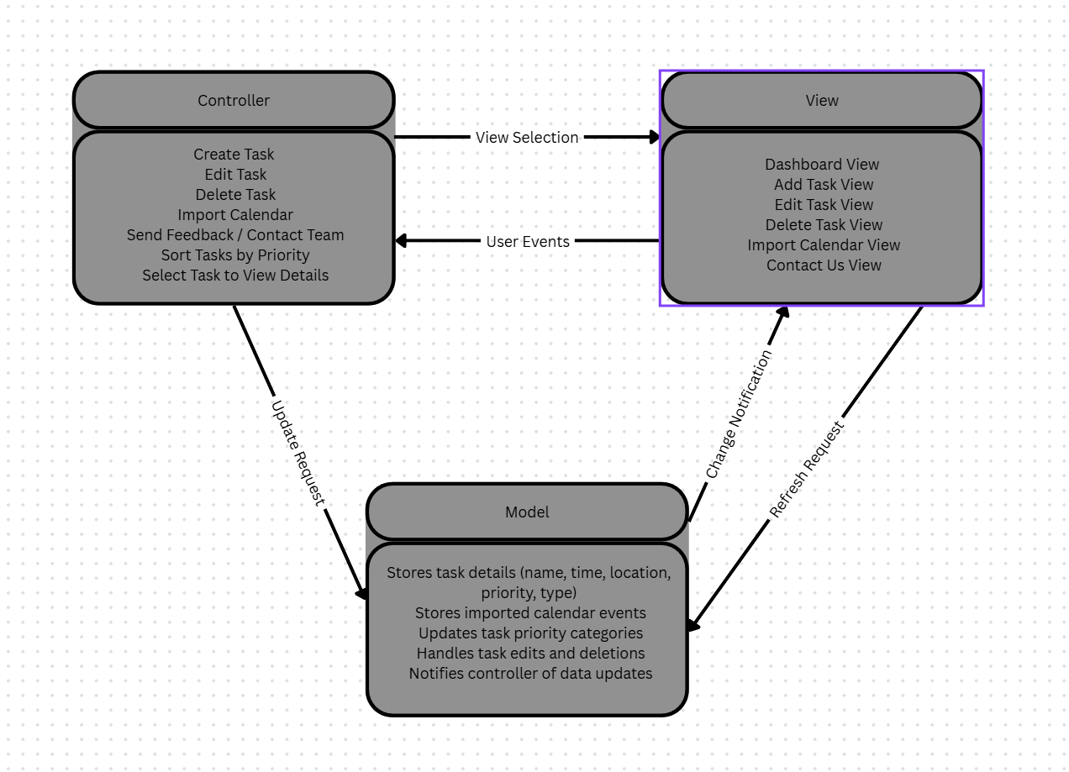
Link to Diagram

Design Description
The architectural pattern consists of three main components: the View, the Controller, and the Model.

View
The View handles the user interface of Busy Bee Calendar. This includes the main dashboard where tasks are organized into three priority sections: Do Now, Something to Think About, and You Can Wait. Each task appears as a card showing the event name and time. The interface also includes buttons and icons such as the plus (+) button for adding tasks, minus (-) button for deleting tasks, edit functionality, and navigation arrows for moving between screens.
The color-coded priority system (red, yellow, green) is implemented in the view layer so users can easily identify task urgency. Urgency is also numbered to ensure color blind users are able to see task priority. The view is responsible for displaying task information, receiving user input, and sending those interactions to the controller. Additional screens, such as Import Calendar and Contact Us, are also handled at the view level.

Controller
The Controller manages the interactions between the user interface and the application’s data. When a user performs an action such as creating a task, editing an event, deleting a task, or importing events from another calendar, the controller processes that request.
For example, when the user presses the + button to create a new task, the controller collects the entered information (priority level, event type, name, time, and location). It validates the input and sends the information to the model to be stored. The controller also handles navigation events, such as moving between the dashboard, edit screen, delete page, and contact page. After processing a request, the controller updates the view so that the user sees the new or modified task in the correct priority category.

Model
The Model manages the data and application state for Busy Bee Calendar. This includes storing task details such as event names, times, locations, event types, and priority levels. When the controller sends new or updated task information, the model saves this data and organizes it based on priority.
The model also handles data retrieved from imported calendars, ensuring that existing events from other systems are correctly added to the application. When data changes occur—such as a task being added, edited, or deleted—the model notifies the controller so the user interface can update accordingly. This ensures the dashboard always reflects the most current task list and priority organization.

